Industry Expert Panel Report
Technology Foresight Exercise

Pakistan Council for Science and Technology
Ministry of Science and Technology
Government of Pakistan

CONTENTS

Disclaimer…………………………………………………….
1.1 Technology Foresight
1.2 Pakistan Vision 2030
1.3 Pakistan Industrial Vision
1.4 Pakistan Current Industrial Policy
1.5 University-Industry Collaboration
1.6 Aims & Rationale of Exercise

Chapter: 1 Engineering Industry – Introduction
1.1 Vision 2030
1.2 Pakistan Industrial Vision
1.3 Pakistan Current Industrial Policy
1.4 University-Industry Collaboration
1.5 Technology Foresight
1.6 Aims & Rationale of Exercise

Chapter: 2 Overview

2.1 Engineering Industry: Situation Analysis
2.2 Sub-Sectors of Pakistan’s Engineering Industry
2.3 National Critical Technologies
2.4 Manufacturing the third largest sector
2.5 SME Sector
2.6 Human Resource Need Assessment
2.7 Training and Skill Development of Technical Workforce
2.8 Training and Skill Development of Management Staff
2.9 Engineering Industry Technology Up-gradation and Acquisition Schemes
2.10 Strengthening and Reorganization of Engineering Development Board

Chapter 3: Expert Panel Findings
3.1 Literature Review
3.2 Methodology
3.3 Scenarios
3.4 Prioritized list of Actions
3.5 Some other recommendations to work on
3.6 Conclusion

Annexure

Annexure I
Annexure II
Annexure III

Disclaimer
The approach we are taking relies upon consulting a wide range of expertise, with the expectation that through our collective experience, imaginative abilities and interactive knowledge of technological development pathways, we can begin to construct a coherent view of some of the major developments that can be anticipated within a 10-25 year time horizon. Foresight is therefore research which can inform the reality of planning, policy and strategic choice amidst uncertainty. This is the nature of foresight - creating a range of plausible future elements that in their diversity should alert readers to the kinds of issues and perspectives they may not have initially considered in longer term research planning and contingency thinking. Accordingly, this report reflects the combined views of the participants, and the best wisdom, and creative thinking that we could stimulate with the tools of foresight, but it clearly does not represent an official view of the Government of Pakistan or any of its Departments and or Agencies.
Prologue
This research report is part of a series of several reports that have been produced for the benefit of sponsors, participants and professionals interested in how emerging and prospective developments in global science and technology might impact Pakistan's future.
The Technology Foresight Exercise (TFE) originated with a proposal made by Pakistan Council for Science and Technology (PCST) to the Ministry of Science & Technology in March 2008, offering PCST's support for a collaborative Exercise to explore the application of foresight tools. Goals of the Exercise were to help stimulate longer term thinking, and to build shared R&D awareness and capacity for engaging broad challenges for which the federal S&T ministry should be better prepared.
Public and Private sector joined together to create a limited duration (i.e. six months) partnership that held five visits to different locations and four panel meetings. The partners and their colleague networks of scientists and industry-academic collaborators contributed over 120 days of professional time to developing the Project's methodology, panel and workshop events and in drafting and reviewing the Technology Foresight Exercise findings.
It is useful to recall the definition of Technology Foresight that was used to define the scope and focus for this Pilot Project:
Technology Foresight involves systematic attempts to look into the longer-term future of science and technology, and their potential impacts on society, with a view to identifying the emerging change factors, and the source areas of scientific research and technological development likely to influence change and yield the greatest economic, environmental and social benefits during the next 10-25 years.

EXECUTIVE SUMMARY

- Energy efficient manufacturing practices may be employed for cost effective product development ranging from fan blades to bicycles and surgical products. This will make the engineering products competitive in the global market.
- The traditional materials i.e. aluminum, iron and steel may be replaced with high performance engineering materials such as composite/ nano/ bio composite materials in sports goods, transport and civil infrastructure industry to enhance the export potential.
- The cost of doing business may be reduced through subsidies and incentives by the Federal/ Provincial government and the process may be facilitated through government ordinance.
- Achieving economies of scale and producing exportable surplus to strengthen the national economy.
- Adherence to standards and quality to improve upon the quality of engineering product and meet the World Trade Order.
- Improvement in entrepreneurship and managerial skills for commercial exploitation of technology from laboratory to production floor.
- Improvement in skill set of work force through effective human resource development
- Acquisition of modern technologies in materials, manufacturing, energy, IT, bio/ nanotechnology and life sciences, aeronautics and surface transportation.
- Becoming a part of global supply chain through integrated foreign/ internal/ science and transportation policies. Being proactive in marketing internationally.
- Research and development for product improvement using innovative design for cost effective manufacturing processes using, high performance materials according to NASA Technology Readiness Levels 1 through 9.
- Improvement in regulatory regimes, facilitation regimes and support infrastructure.
- Inculcation of export culture in Engineering Industry.
TECHNOLOGY FORESIGHT

What is Technology Foresight?
Technology Foresight (TF) can be described as a systematic approach in which various methodologies and techniques are combined in order to create a better preparedness for the future.
Technology Foresight is neither about delivering probabilistic predictions of the future technologies (Technology Forecasting) nor is about anticipating the impacts of future technologies in today’s society (Forecasting Assessment), rather Technology Foresight is a Systematic Process to visualize Science, Technology, Industry, Economy and society in the long run, with the purpose of identifying technologies that can generate economic and social benefits. Pakistan is the 25th country which has undertaken Technology Foresight program.
The methodologies used and exercises conducted were framed by six fundamental pillars of future studies – mapping, anticipating, timing, deepening, creating (alternatives) and transforming the future.
Foresight is by nature multi-disciplinary, requiring the expertise of disparate groups in order to combine scientific and technological expertise with an understanding of society, economy and environment. It is usually intended to have a major impact, and often includes controversial issues where there are lots of vested interests. This is especially true of priority setting for the allocation of resources, which is a common application of foresight.
Foresight’s role is
- to help government think systematically about the future.
- to give ownership of decisions to all stakeholders for adoption of policies and their implementation.
- to promote culture of future oriented thinking.
- to promote networks between ministries, departments, institutions and companies.

Project Objectives
Based on a decision taken by the Pakistan Council for Science and Technology, a sectoral and nationwide Technology Foresight exercise was proposed. This approach aims at enabling the Government’s intention of uplifting key sectors through improved operation of limited national resources. It results in selecting public policies needed to align scare resources for supporting assimilation of technology by the industry. Additionally, Technology Foresight fosters increased rate of national innovation. This is achieved through the rigorous application of those Technology Foresight strategies, techniques, and methodologies that have proven successful in other countries, and are also conducive to our country’s milieu.

Specific Objectives
According to the United Nations Industrial Development Organization (UNIDO), Technology Foresight is the systematic process of visualizing science, technology, society, and economy in the long-term, with the purpose of building consensus to identify technologies, which will cause the greatest social and economic benefits.
Technology Foresight in Pakistan has been implemented to provide valuable inputs to strategy and policy planning as well as to mobilize collective strategic actions. It aims at doing so by:
- identifying potential opportunities for the economy or society from new science and technologies, and
- considering how future science and technologies could address key future challenges for the Pakistani society.
Pakistan’s Foresight program involves constructively bringing awareness of long-term challenges and opportunities into more immediate decision-making. It looks beyond normal planning timescales to identify potential opportunities from new science and technologies. It, then take actions to help realize these opportunities. It brings together scientists, technologists, businesses and consumers, with those who can help deliver benefits. This leads to a systematic process for discussions on the future.
The consultations facilitate identification of policies and projects. The starting point for a policy or a project recommendation is a key issue where science holds the promise of solutions (e.g. information and communication technologies, in which Pakistan has already invested considerably). In addition, it may be an area of cutting edge science where the potential applications and technologies have yet to be considered and/or articulated more broadly (e.g. biotechnology, nano-technology). Foresight policies and projects will:
- Encourage the creation of new networks between science, business and society
- Have the support of at least one of the interested communities (Government, research funders, business, etc)
- Add value to existing activities and initiatives – with the scope to deliver outputs that would not otherwise be achieved.

Methodology Adopted

Technology Foresight experts all over the world use different methods and tools to conduct this activity. These methods and tools are adopted according to the availability of resources. Since this project at PCST was launched at a time when severe economic crunch was being faced by the government, therefore budget and manpower was not provided according to the envisaged plan as per PC-I.
Keeping in view the limited resources at hand, expert panel method was used by the project team. However in order to find out the priority areas on which the foresight study needed, a mini Delphi Survey was carried out. As a result of this nationwide survey, ten sectors were identified, namely, ---- Energy, Agriculture, Industry, Education, Environment, ICT, Health, Materials, Transportation and Management.
Expert panels were formed on each of the above sectors, comprising of all the stakeholders. These panels held their meetings in which brainstorming sessions using STEEPV and Scenario Planning methods were invariably used. During panel meetings presentations by other experts were also arranged. Subgroups to handle specific tasks were also formed.
As a result of the meetings, recommendations pertaining to policy, projects, along with roadmaps were produced.

TERMS OF REFERENCE

The Terms of Reference of the Expert Committee were:
- The panel will work as a Think Tank, in a particular field, for the Government of Pakistan using Technology Foresight process.
- The panel shall review the issues related to development in the respective fields, suggest short, medium and long term strategies, to be undertaken by the government of Pakistan, for strengthening S&T activities required towards industrial and economic progress in Pakistan.
- The panel shall identify and prioritize R&D projects of high national importance by considering short, medium and long term development that need to be supported by the Government of Pakistan.
- The panel will work for duration of six months, at the end of which a comprehensive report, indicating the current status vis-à-vis strengths, weaknesses, opportunities, and threats of the sector under study.
- Recommendation of implementable policies and projects will be the final tangible outcome of the exercise, in addition to more desired intangible outcome i.e. process benefits.

Chapter: 1
Engineering Industry

Introduction

Science, technology and innovation policies are central to success in today’s modern economy i.e. knowledge based economy. They are vital resources and strategic investments for building a more innovative and vibrant economy in order to face the challenges and uncertainties of the 21st century. Since long all advanced countries and some developing countries have showed strong commitment to study policy issues relating to the development of S&T with the national development, priority areas in line and probable future scientific and technological developments, etc.
Hence, facing the globalized economy recession, many countries including Pakistan have realized how technologies, knowledge, political and social maintain industrial competitiveness, and are implementing technology policies, working on research and innovation, and promoting nation upgrade in order to stay competitive in the global competition. Presently, technology foresight is considered a right tool to identify the priority areas in this age of technologies and competition. In hand study was undertaken, in this context, by Pakistan Council for Science and Technology (PCST) with the financial assistance of Ministry of Science & Technology, Government of Pakistan.
1.1 Vision 2030
A document “Vision 2030” was the fruit of concerted efforts of scientists and planners which was published by Planning Commission of Pakistan in 2007. The Vision 2030 is an important milestone in our journey of socio-economic development.
The Vision document necessarily combines idealism with a sense of the possible. Its goals reflect the aspirations and potential of our people in the context of a fast changing world. The Vision 2030 exercise considers a range of futures with concomitant strategic alignments. Yet the underlying theme is to embrace needed transformation, and to create new opportunities based on our innate strengths. This is the basic theme of Vision 2030.
In order to stay ahead in the race of Global competition, the prime goal set in Vision 2030 document “developed, industrialized, just and prosperous Pakistan through rapid and sustainable development, in a resource constrained economy by deploying knowledge inputs”.

Vision 2030 envisages the share of the manufacturing industry sector to change from the current 18.3 percent of GDP to nearly 30 percent (or USD 300 billion in current terms) by the end of the Vision period. This requires the sector to grow at a sustained average growth of around 10 percent. To meet this ambitious target, Pakistan has to quickly put in place the necessary human, technical, legal and physical infrastructure.
These are the instruments needed for matching of trans-national skills, so that investments and possible relocation of manufacturing and design from developed economies can be facilitated. While excellence of public institutions and stability of macroeconomic policies are basic requirements, the driving force will remain flexible, skilled and innovative technical personnel; and fast and efficient physical and electronic connectivity.
Global demand for goods does not match what Pakistan produces and sells, as shown in Figure 1.1 which highlights the composition of world trade for 2005 (WTO). The four sectors having the largest share in world trade are machinery, electronics, pharmaceuticals, automobiles, and agricultural products.
Figure-1.1 Global Demand for Pakistani Goods

The vision for manufacturing aims to strengthen present industrial activity and enhance its output and productivity, so that it can become competitive, flexible and agile.

1.2 Pakistan Industrial Vision

This document presents a strategy for socio-economic development and rapid economic growth, with a pivotal focus on science and technology. In this document key issues and challenges identified in background of in-depth analyses of major productive sectors of the economy, sets outs strategic objectives and targets, and spells out detailed action plans to realize the desired goals.
The document, Technology – Based Industrial Vision and Strategy for Pakistan’s Socio -Economic Development is a result of concerted efforts of eminent scientists, planners and visionaries, and lays down the framework for the future development of the country.
The strategies and vision presented the document is pictured in the below lines.

Vision: The long run industrial vision of Pakistan comprises rapidly growing, broad-based, dynamic and efficient industrial sector that can compete in a highly competitive global economic environment. It can be realized by diversifying the industrial base through higher investments and strengthening technological base of the country. These objectives can only be realized through a coherent short, medium and long run strategy. Key elements of the proposed strategy in this study are reliance on the private sector for growth and development, while the role of public sector will be of a facilitator and an efficient regulator; and the development of science and technology and its interface with the industry.
Strategies: There are three technology policy instruments, viz. technology transfer, technology diffusion, and indigenous R&D. With a view to realizing the objective of technology transfer, diffusion and development, technology infrastructure needs to be strengthened. This can be overcome by Human resource development through education, health, nutrition and training, the key determinant of productivity, and development of S&T personnel in which science and technology personnel of high quality are basic. Clusters of industries connected through vertical and horizontal relationships in Pakistan may be developed. Government may set up an Authority for improving the existing industrial clusters and creating more clusters, by acquiring full knowledge of the problems being faced by the specific industries and creating such facilities required to improve the quality of products with higher productivity.
Technology foresight exercises should be regularly carried out to assess the present and future needs of technology, the niche opportunities for Pakistan and the projected impact of such technologies on social, economic, health and environmental aspects. Efforts are needed to promote R&D and technological innovation, to introduce technologies through strategic incentivisation and to diffuse technologies to the production sectors for which effective mechanisms will need to be developed and implemented.
1.3 Pakistan Current Industrial Policy
This National Industrial Policy 2010 was developed by the Core Group by the Ministry of Industries & Production, Government of Pakistan. The vision in this policy for Pakistan is highlights that of a factory for the world rather than a shop. It hoped that in the next ten years, Pakistan would establish itself as a formidable manufacturing economy producing for an expanding domestic market as well as for the world market.
The main goals of this policy are outlined below;

- Pakistan’s manufacturing output per worker has grown by a paltry 1.5% per year over the past 10 years. Its share in GDP has also stagnated in these past 10 years. Through value-addition and diversification this policy aims to increase the manufacturing output per worker by at least 100% in the next 10 years. This increase is expected to enhance the manufacturing share in GDP to at least 30% in the next twenty years as envisioned in the Vision 2030.
- By a conservative estimate, more than one-third of Pakistan’s labour force is unemployed or under-employed. In addition, about two million people join the labour force every year. While the services sector in Pakistan continue to be critical for more job creation, this policy aims to expand Pakistan’s manufacturing base and 6 impart focused skill-based training to the labour force in order to productively employ the young population of this country.
- Currently, Pakistan’s manufacturing industry is concentrated in a few developed districts, which attract a disproportionately high allocation of development funds. This unbalanced industrial development is unsustainable because it leads to growing disparity and deprivation, which in turn fuels resentment and political unrest. This policy aims to spur development across the country to stem this undesirable progression.
1.4 University-Industry Collaboration
University-industry cooperation (UIC) in research is an important vector of innovation and growth, being one of the avenues to foster a dynamic research sector while strengthening the so-called third mission of universities. UIC has strategic importance as it brings opportunities for universities to improve the sharing of research results, intellectual property rights, patents and licences (for example through on-campus start-ups or the creation of science parks). Universities can also increase the relevance of education and training programmes through placements of students and researchers in business, and can improve the career prospects of researchers at all stages of their career by adding entrepreneurial skills to scientific expertise. Links with business can bring additional funding, and enhance the impact of university-based research on SMEs and regional innovation.
It is an age of competition only those nations will stay in international markets who pay their due attention on university-industry collaboration cause of important vectors of innovation and economic growth. It is the necessary instrument for Pakistan “….to advance productivity and competitiveness through jointly developed curricula, research programs, and university-industry collaborations”.
1.5 Technology Foresight
The “use of technology foresight as tool in S&T policy making: A Korean experience”. It learned that “technology foresight” (TF) is quite hard to grasp, define and classify. It is a policy analysis tool, but also more. It is because TF expresses and reflects specific features of the times. This makes TF difficult to describe in its entirety and difficult to transfer from one country to another. Nevertheless they all have five important aspects in common (Martin 1995).
- attempts to look systematically into the future;
- must be concerned with the long term, which is generally considered to be beyond normal planning horizons;
- must be balanced between science/technology push and market pull
- concentrates on emerging generic technologies where there is a legitimate case for government support;
- must attend to social impact, not just impacts on wealth creation.
Technology Foresight (TF) can also be described as a systematic approach in which various methodologies and techniques are combined in order to create a better preparedness for the future. Technology Foresight is neither about delivering probabilistic predictions of the future technologies (Technology Forecasting) nor is about anticipating the impacts of future technologies in today’s society (Forecasting Assessment), rather Technology Foresight is a Systematic Process to visualize Science, Technology, Industry, Economy and society in the long run, with the purpose of identifying technologies that can generate economic and social benefits.
Moreover, TF is a participatory approach to creating shared long-term visions to inform short-term decision-making processes. It is used by policy professionals who work at the level of the nation, the region of the municipality; at the level of the research system, the industry sector or the cluster; and at the level of the supply chain or production system. TF mobilizes actors and creates broadly based support for policies that are so developed.
TF has been increasingly recognized worldwide as a powerful instrument for establishing common views on the future development strategies among policy-making bodies. Foresight is by nature multi-disciplinary, requiring the expertise of disparate groups in order to combine scientific and technological expertise with an understanding of society, economy and environment. It is usually intended to have a major impact, and often includes controversial issues where there are lots of vested interests. This is especially true of priority setting for the allocation of resources, which is a common application of foresight. The role of TF is outlined below;
- to help government think systematically about the future.
- to give ownership of decisions to all stakeholders for adoption of policies and their implementation.
- to promote culture of future oriented thinking.
- to promote networks between ministries, departments, institutions and companies.
1.6 Aims & Rationale of Exercise
In the era of globalization, the key to economic success lies in continuous innovation to achieve ever-higher productivity and thus enhanced competitiveness. Higher productivity calls for new technologies. Thus, technology innovation is decisive for increased competitiveness and economic and social development.
As science and technology are among the main drivers of change, TF activities are an important vehicle in promoting broad social debates based upon expert inputs and mobilizing broad sections of all stakeholders to give collective thought on priorities and actions. Bringing together experts with people from different disciplinary and sectoral backgrounds, makes it possible that besides possible impacts on policy-making of the products of TF activities, the processes that lead to that output also change the perceptions and beliefs of the participants.
Keeping in view the running scenarios of water & energy in country and goals set in Vision 2030 to have industrialized & prosperous Pakistan, Pakistan Council for Science and Technology was launched “Technology Foresight Exercise in Pakistan (2009)” with financial assistance of Ministry of Science & Technology, Government of Pakistan. Pakistan is the 25th country which has undertaken Technology Foresight program.
It is expected that the approach (TF) would leverage upon the Government’s intention of uplifting key sectors through improved operation of limited national resources. It will help in framing sound and flexible S&T policies. The main objectives of this study are described as;
Objectives
- Identifying potential opportunities for the economy or society from new science and technologies.
- Considering how future science and technologies could address key future challenges for the Pakistani society and;
- Encourage the creation of new networks between science, business and society
- Have the support of at least one of the interested communities (Government, research funders, business, etc)
- Add value to existing activities and initiatives – with the scope to deliver outputs that would not otherwise be achieved.

Chapter: 2
Engineering Industry

Overview

Pakistan’s Engineering Goods Industry, despite being small in terms of size, contribution to GDP and exports, has a large potential to grow and contribute in GDP and exports. The engineering sector is diverse and all its sub-sectors have their own dynamics and value chain. The engineering sector is largely dependent on imports for its inputs, is technology & knowledge intensive and employs relatively more skilled people than other sectors. Owing to continuous need for skill, product design and manufacturing process improvement, it faces altogether a different challenge to compete internationally. Pakistan’s engineering sector has proven to be robust and dynamic and has shown promising growth during the last few years. The engineering sector registered an export growth of 26% (in selected non-traditional sub-sectors) during 2008-09 over 2007-08, at a time when other sectors were showing contraction. The Minister for Commerce rightly praised the performance of Engineering Industry in his annual policy speech, 2009.

Engineering Industry, has been operating under the same set of regulatory and facilitation regime, which the other traditional sectors like textile, leather, etc. avail. In fact the regulatory and facilitation regimes were designed and implemented for sectors like textile and would always work to the detriment of engineering sector instead of benefitting. It remains imperative to appreciate the fundamental challenges confronted by the Engineering Industry which is different in many ways from rest of the industrial economy. There has seldom been a structured and elaborate debate on the core challenges faced by the Engineering Industry. The governmental policies and their formulation process have also been devoid of clear projections; identification of key products; competition and complementarities analysis; the required facilitation framework through specific set of regulations & incentives; and their implementation and follow up. Generally, the Engineering Industry itself, unlike other export oriented sectors of textiles, leather, etc has not been forthcoming in framing issues, seeking solutions and projecting its potential, due mainly to relative in-experience and less awareness of the regulatory and facilitation regimes. Similarly, the key governmental agencies are also less aware of the Engineering Industry, its issues and potential. With these fundamental realities in mind and the fact that Pakistan’s future lies only in developing a competitive Engineering Industry,

Pakistan’s Engineering Industry has a large potential to grow and contribute towards GDP and exports. It is diverse and all its sub-sectors have their own dynamics and value chain. On one hand, the diversity can become a challenge while on the other, it provides an opportunity of growth due to a wide canvas. Pakistan’s Engineering Industry has proven to be robust and dynamic and has shown promising growth during the last few years even in difficult times when other sectors of economy did not perform well. However, the huge potential of export growth in engineering goods remains unutilized due to multiple reasons. The government did not focus on Engineering Industry with all its possibilities as it has remained busy in promoting other traditional export sectors. Also, the Engineering Industry itself has not been forthcoming in framing issues, seeking solutions and projecting its potential.

2.1 Engineering Industry: Situation Analysis
Engineering Industry in Pakistan had a very humble start. It inherited a negligible capacity to produce engineering products. It comprised of small workshops producing diesel engines, lathe machines, manual cane crushers, etc in and around Lahore. There was also small scale manufacturing of surgical instruments in Sialkot, cutlery in Wazirabad and kitchen utensils in Gujranwala. Karachi, Khairpur Mirs and Peshawar also had small workshops manufacturing small daily use items. The only large engineering unit, the Muglahpura Engineering Workshop, was exclusively engaged in production of railway machinery and stock. For almost 10 years after the independence, the Engineering Industry remained muted. Its below the line operations were unorganized, but it kept itself alive through the efforts of mechanics, craftsmen and immigrants who had inherited workmanship from earlier generations (cluster of Kotli Loharan) or were ex-employees of large industrial units in India.

- Although a large part of it expanded as unorganized segment and remained involved in below the line manufacturing, some entrepreneurs did made efforts to organize themselves to manufacture engineering products. Most of them were successful as a large vacuum existed in the domestic market place in respect of engineering goods and products. Their operations were small to medium scale and they were producing basic mechanical and electrical products. A lot of credit needs to be given to them as these people laid the foundations of Engineering Industry in Pakistan. The high turn was the entry of Public Sector Corporations in engineering sector. The public sector made huge investments in the shape of Heavy Mechanical Complex, Heavy Foundry and Forge, Heavy Industries Taxila, Telephone Industries of Pakistan, Pakistan Aeronautical Complex, Precision Engineering Complex, PIA, Pakistan Machine Tool Factory, Pakistan Engineering Company, Pakistan Steel, and a few other units. Although these units were not a financial success, they did play a huge economic role in further strengthening of the Engineering Industry. A higher level base for the industry was created in this phase. The Engineering Industry has since made progress form where it started. It now produces automotives and parts thereof, home appliances, electrical machinery and equipment, heavy sheet metal fabrications, industrial machinery, forgings and castings, tractors, farm machinery & equipment, electrical fittings, fans, pumps, wires & cables, pipes, and a lot of other products. Reaching at this stage has not been easy. Maintaining its current status is at times difficult and proceeding further from here would surely be more difficult.

- Engineering Industry’s biggest problem lies in its very roots. It started as unorganized small workshops, manufacturing small items on conventional methods and machines. The transfer of knowledge and methods from teacher to student without exposure to new and modern techniques gave rise to a culture of small sized isolated & fragmented units now numbering in thousands and scattered throughout Pakistan. Even in cases, where manufacturing activities are clustered in and around townships and cities, the size of individual units remained small. Only they grew in numbers. The smallness of size is always associated with other allied issues like managerial and technical capability to run an efficient business, weak financial position, inability to acquire new technologies & productive assets, low economies of scale, little outreach to market & sell and many others. So, the very phenomenon which helped start engineering activity in Pakistan is keeping it to the ground and not allowing it to rise high. These units need to be organized and supported through a strong institutional framework so that they are not only able to survive but also grow to medium sized units producing quality goods. In fact, a small number has already managed to reach medium scale and is performing well. Others only need to follow them.

- The entrepreneurs who started later as small to medium scale units have also made progress. They had to face the low quality cheap products supplied by unorganized units domestically and also had to face imports coming from big industrial houses having large economies of scale. Some could not survive. But those who did, learnt their lessons, made adjustments, increased product mix, expanded and are today the forerunners of Engineering Industry. Some of them have even grown big. They now produce goods as mentioned earlier in this chapter. To grow further from here, they also face a set of barriers and challenges. They need to expand but bank financing is hard to come by and is prohibitively expensive. The manpower needed to produce high end products is not available. The regulatory regime is not conducive enough to facilitate progress. Support from the Government to enter export markets is not enough. The internal changes these units need to make are structural. The international linkages to enter global market get discouraged by the geo-political situation of the region. To overcome these challenges and barriers, the government and the industry need to work together and create a winning position for all.

- Some foreign investment has also come in the engineering sector. Largely, it is in automotive sector. However, it is also visible in home appliances, electrical machinery and pumps. An endured presence of foreign investment in engineering sector does indicate the confidence of international players in Pakistan’s engineering economy. In fact more foreign investment is needed. It has a huge economic impact as with investment, the technology, knowledge, new skill and exposure also becomes available. Once these factors are absorbed into the engineering culture, the Engineering Industry can move towards next step of its evolutionary development.
- Starting from a negligible base and spending initial time quietly, the Engineering Industry has come a long way. But, this long way can also be described as half way because the industry is yet to match or even get closer to leading engineering economies of the world. Since detailed information and data on industry’s performance is not available, here reliance has to be placed on macro data. Pakistan still imports a lot of engineering goods. Share of engineering goods in total imports has ranged from 33% 40% over the last five years. During the last financial year, Pakistan’s total imports were US$ 34,695 million out of which engineering goods accounted for US$ 11,545 million. Although, exact local production and supply figures are not available due to unorganized nature of industry, it can easily be stated that a lot of domestic market space is occupied by imported engineering goods. It is an opportunity lost for the industry. Can they gain on this space in coming years? It is too early to guess on this question. However, the industry does appear to be preparing to gain on the domestic space. The results would depend on the sustained efforts of the industry and creation of an enabling environment by the Government.

2.2 Sub-Sectors of Pakistan’s Engineering Industry
The scope of Engineering Industry is very large and diverse, form the simplest of processes to the most intricate. The range of the engineering products is also very wide. From simple metal works to intricate electronics, it produces an unimaginable range of products. Individual dynamics of each of its products, whether upward production processes or downward marketing and sales, are different from each other.
- Industrial Machinery and equipment
- Automotive Vehicles
- Motorcycles and Auto Rickshaws
- Autoparts
- Tractors, Farm Machinery and equipment
- Home Appliances (Electrical)
- Cutlery, Blades and kitchenware
- Surgical Instruments
- Electric Fans
- Iron and Steel Pipes and Tubes
- Pumps
- Other Sub-Sectors and products:
  - Electrical Machinery
  - Electrical Fittings.
  - Wires & Cables
  - Valves and Flanges
  - Steel Structures
  - Prefabricated Buildings
  - Special Purpose Vehicles
  - Castings and Forgings

2.3 National Critical Technologies
The US government has identified 22 technologies deemed to be critical to the national economic prosperity and national security has also been identified early in 1991. The selection of these national critical technologies was carried out by a panel appointed by the Director, Office of Science and Technology Policy, Executive Office of the President. The panel included senior federal agency and private sector officials who are responsible for technology development and application. The National Critical Technologies selected by the panel are listed in Table 1.2. These technologies fall into six broad areas:

Materials with properties that promise significant improvements in the performance of items produced and used by virtually every sector of the economy.

- Materials synthesis and processing
- Electronic and photonic materials
- Ceramics
- Composites
- High performance metals and alloys

Manufacturing processes and technologies that can provide the basis for industry to bring a steam of innovative, cost competitive, high-quality products into the market place.

- Flexible computer integrated manufacturing
- Intelligent processing equipment
- Micro- and nanofabrication
- System management technologies

Energy and Environment related technologies which have the potential to provide a safe, secure, and enduring source of energy and ensure that a healthy environment is preserved for the use of future generations.

- Energy Technologies
- Pollution minimization, remediation and waste management

Information and Communications technologies which continue to evolve at a breath-taking pace, permanently changing our approaches to communication, education, and manufacturing.

- Software
- Microelectronics and optoelectronics
- High-performance computing and networking
- High-definition imaging and displays
- Sensors and signal processing
- Data storage and peripherals
- Computer simulation and modelling

Bio/ Nanotechnology and Life Sciences advances that will permit unconventional approaches to major problems in such diverse fields as medicine, agriculture, manufacturing, and the environment.

- Applied molecular biology
- Medical technology
- Nanotechnology

Aeronautics and Surface Transportation systems that enhance our civilians capabilities and increase the ease and safety of travel.

- Aeronautics
- Surface transportation technologies

It is expected that the national critical technologies will constitute appropriate bases for exploitation to satisfy the Pakistan’s future industrial needs.

2.4 Manufacturing the third largest sector
For a long time the basis of Pakistan’s industrialization strategy was large scale manufacturing which recorded 8.78% growth rate during 1950-2003 as it was consistently supported by a set of macroeconomic policy measures. The small-scale sector too registered an impressive growth rate of 5.06% during 1950-2003 and that too without benefiting directly from policy support.

Manufacturing is the third largest sector of the economy, accounting for 18.5 percent of Gross Domestic Product (GDP), and 13 percent of total employment (see table 1). Large Scale Manufacturing (LSM), at 12.2 percent of GDP, dominates the overall sector, accounting for 66% of the sectoral share, followed by Small Scale Manufacturing, which accounts for 4.9 percent of total GDP. The third component of the sector is Slaughtering, which was separately included as a sub‐category from 2003‐04, and accounts for 1.4 percent of overall GDP.

Table 1: Share of Manufacturing

Manufacturing as % of: 2000 2005 2010

GDP 14.7 18.3 18.5
Employment 11.5 13.6 13.0
Fixed Investment 23.0 22.0 16.2

Source: Federal Bureau of Statistics

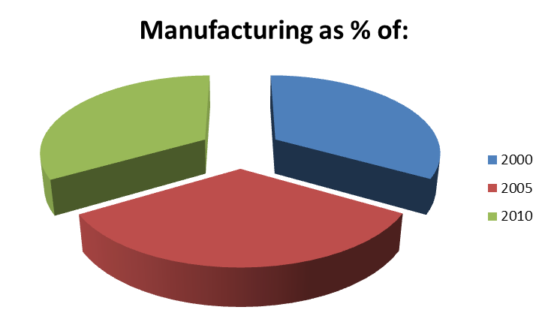

Manufacturing sector in regional countries
As % of GDP

1995 2007
Thailand 30 35
China 34 32
Malaysia 26 28
Indonesia 24 27
Vietnam 15 21
Cambodia 10 19
Pakistan 16 19
Bangladesh 15 18
Manufacturing sector in regional countries
As % of GDP
India 18 16

Manufacturing sector in regional countries
As % of GDP

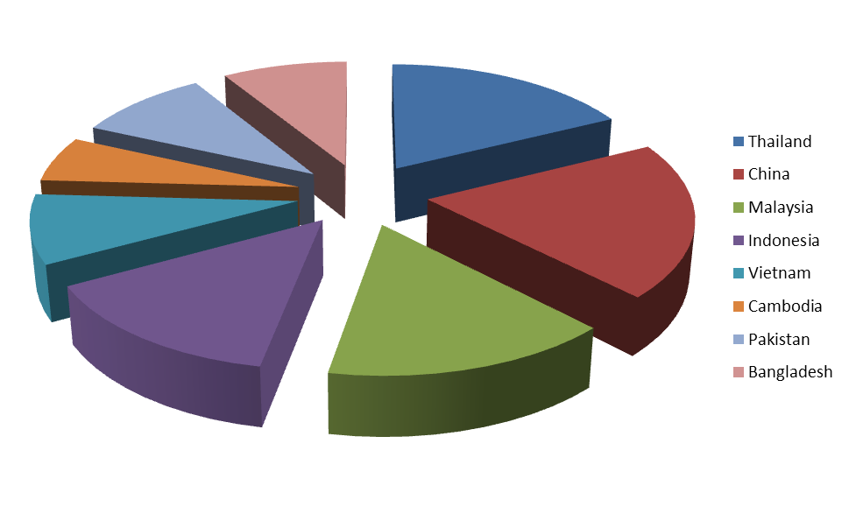
(Source: World Bank)

Source: World Bank

Cotton textile production and apparel manufacturing are Pakistan's largest industries, accounting for about 66% of the merchandise exports and almost 40% of the employed labour force. Other major industries include cement, fertilizer, edible oil, sugar, steel, tobacco, chemicals, machinery, and food processing.

2.5 SME Sector
In Pakistan SMEs have a significant contribution in the total GDP of Pakistan, according to SMEDA and Economic survey reports, the share in the annual GDP is 40% likewise SMEs generating significant employment opportunities for skilled workers and entrepreneurs. Small and medium scale firms represent nearly 90% of all the enterprises in Pakistan and employ 80% of the non-agricultural labour force. These figures indicate the potential and further growth in this sector.

2.6 Human Resource Need Assessment
Human resource is an important factor of production. Without it, the wheel cannot rotate. The input materials, capital goods and financial resources are equally important but even they are products of human endeavour. Pakistan possesses this resource in abundance. However, very little has been done to make human resource useful so that it can be employed to meet ever increasing economic and development challenges faced by Pakistan. The entire world acknowledges the benefits of having a properly trained, skilled and mobile workforce in whom work ethics have been imbibed. All the leading countries of the world invest heavily in skill development, vocational training and technical education relevant to their work places. Unfortunately, Pakistan has fallen behind on this account. The results are obvious. Firstly, the workforce finds it difficult to get a job because in most of the cases they are without the required training and skills. Secondly, the employers do not find the workers with required skill set and have to make do with unskilled or semi skilled workforce. This results in low productivity of manpower impacting on productivity of plant, machinery & equipment and reducing the yield on financial capital. The so called low cost manpower, therefore, becomes heavy on cost of production and consequently becomes high cost manpower.

The Engineering Industry needs high skill levels in all traits in order to remain productive and to maintain quality. More so, to remain cost competitive and achieve export growth, a highly skilled workforce with diversified skill set is needed. The Government of Pakistan has been putting efforts to improve this situation. NAVTEC at Federal level as well as provincial TEVTAs have the mandate to improve skill set. Their effort has brought some results at limited scale and a lot of ground still needs to be covered. The current skills level available in manpower is quite low as compared with international and even regional standards. The percentage of production staff trained by occupation is only 4%. In comparison, India’s performance is 7% and that of Sri Lanka is 22%. On the management side as well, the trained manpower is only 2% in comparison to India at 6% and Sri Lanka at 11%. All put together there are 61 Polytechnic Institutes/ Colleges of Technology in public sector and 47 such institutes in private sector. The total number of vocational institutes is 310. Out of this total of 418 institutes less than 25% relate to vocations relating to Engineering Industry. In the given situation, it can easily be stated that even to sustain the organic growth in Engineering Industry, the training and skill imparting effort needs to be improved substantially.
The skill pyramid of technical manpower (Fig 10.1.1) is indicative of the kind of training needed at various levels within the Engineering Industry. The same is also explained as below:

- Basic Trade Level:
The need of theoretical knowledge is low (5%) and the operating skill level is high (95%). These workers repetitively perform predefined tasks without much understanding as to why they are doing what they are supposed to do.
- Diploma Technicians:
The need for theoretical knowledge is low (20%) and the operating skill level is high (80%). These technicians essentially manage the equipment, processes and people. They contribute to shop floor management as well.
- Technologists:
The need for theoretical knowledge is 40% with operating skill level of 60%. They are incremental modifiers of equipment and processes. They also provide supervision for technicians and basic trade level workers.
- Engineers:
These are translators of theoretical knowledge & concepts into equipment and processes.
- Scientists:
Scientists are at the top of the skill pyramid. They make discoveries and develop fundamental principals.
The Engineering Industry of Pakistan needs trained basic trade level workers, diploma technicians and technologists in a big way. The functional set of trainings which are needed relate to the skills listed below. However, it must be kept in mind that the list is only indicative and not exhaustive.

- Welders
- Fittters
- Machinists
- Polishers
- Forging workers
- Foundry workers
- Metallurgists
- Machine Operators
- Sheet Metal Workers
- Fabricators

The need of the Engineering Industry of Pakistan in the current scenario may be limited to basic trade level workers, technicians and technologists. However, a few engineers are also needed. With further growth, the need for engineers would increase. Pakistan’s Engineering Industry envisages an accelerated growth in its manufacturing activity to meet its export targets. Further investments in productive assets, technologies, etc are due to be made. To manage all this and to operate at optimum level, a need assessment was done for the additionality of technical manpower requirements needs using the law of averages. It was estimated that to meet the increased needs of Engineering Industry approximately 1,500,000 basic trade level workers, technicians, technologists and engineers would be needed over next fifteen years.

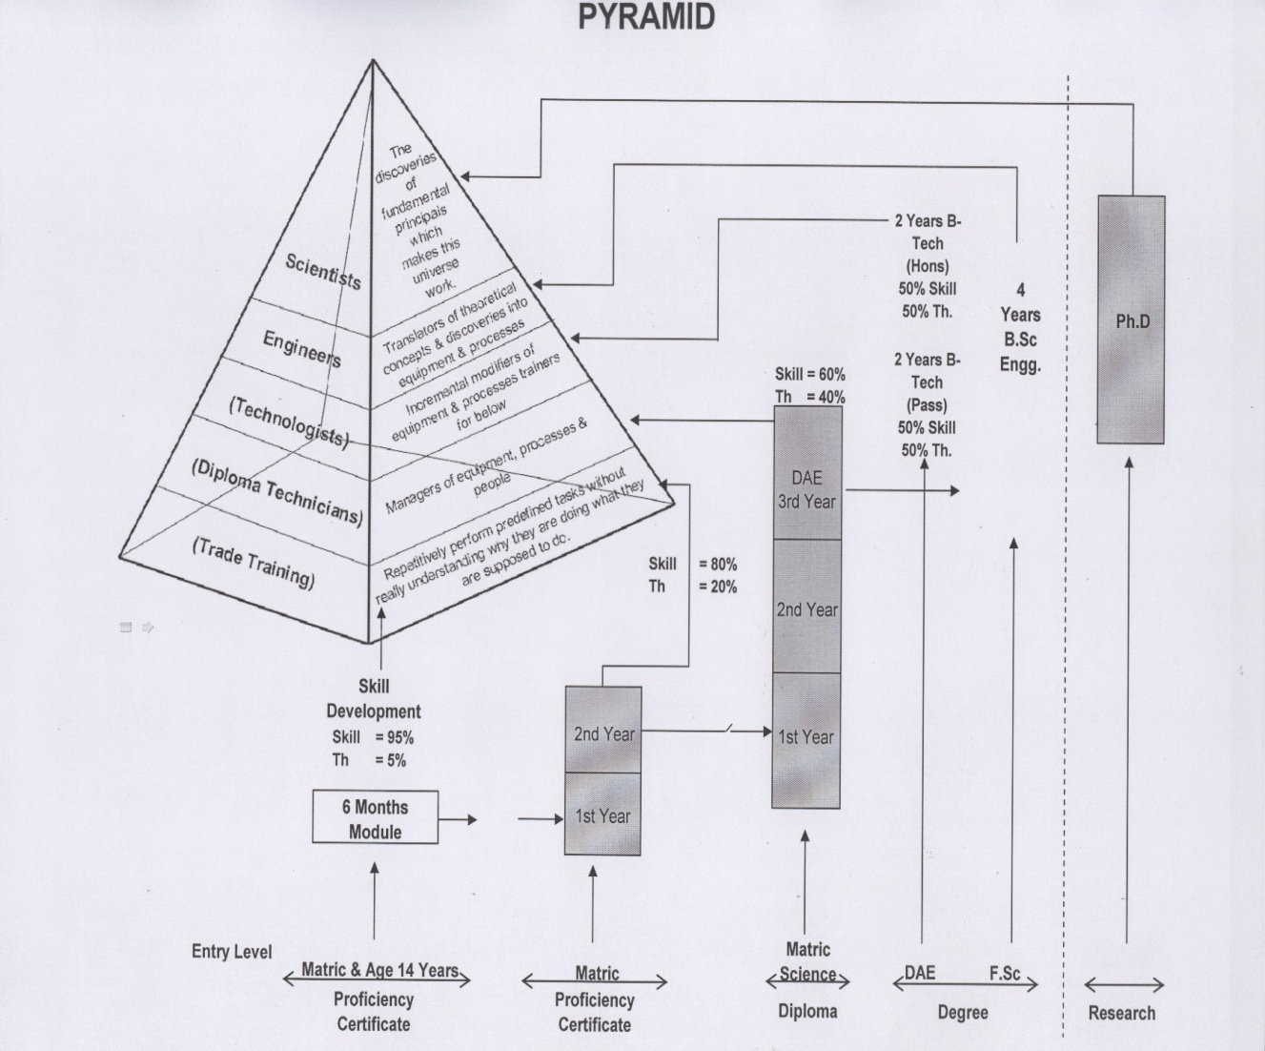

In addition to the above, the management capacities of Engineering Industry would need to be enhanced. The industry would require trained management staff to deal with human resource, financial issues, strategic management, logistics, marketing and sales. A number of universities and other institutions are churning out business graduates every year in thousands. The management skill set available with such graduates is usually not relevant to Engineering Industry. Firstly, they are mostly taught theory which is not relevant to the work environment of Pakistan. Secondly, the designed exercises they conduct during their studies are not relevant to work environment here. And thirdly, they have no local knowledge, especially that of Engineering Industry. To serve the needs of Engineering Industry management, it would be more prudent if the educational institutions lay more stress on applied side rather than theory. Skill sets relating to the local work environment, regulatory environment, trade related laws and fiscal laws need to be developed as well. A need assessment was done to determine the additional management staff which may be needed to support future export business of Engineering Industry in an expansion mode. Additional management staff requirements were estimated to be approximately 100,000 over the next fifteen years.

The assessment of additional requirements of technical and management related manpower has been made. The NAVTEC, TEVTAs and other institutions are to be informed of the needs in number as well as quality of skill sets. This domain is essentially of HEC, NAVTEC and TEVTAs. To deliver on the need, they are to have a lot of linkages with Engineering Industry to have their continuous input to design curriculum and run relevant courses. It is, therefore, proposed that Advisory Bodies may be constituted within HEC, NAVTEC and TEVTAs for providing input to them regarding needs of Engineering Industry. Similar bodies for other industrial sectors already exist within NAVTEC. Further proposals regarding contribution to skill development by private and public sectors are covered in proceeding sub-chapters.

2.7 Training and Skill Development of Technical Workforce
The Engineering Industry of Pakistan is expected to make an investment of over US$ 7.5 billion (or over Rs. 600 billion) in the next 15 years. With this investment, new productive assets and modern technologies would be acquired. A new knowledge base and higher level of skill set would be needed to operate and maintain these physical and intellectual assets. The existing state of skilled and trained human resource is not sufficient for the present productive assets and technologies and manufacturers feel deficient in this respect. With the increase in quantity and quality of productive assets and technologies, the situation may become desperate. It is, therefore, imperative to make out a plan to meet the challenge of technical human resource need upfront.

The availability of the existing number of technical training institutes, colleges and universities have proved to be insufficient to meet the demands of industry, quantitatively as well as qualitatively. NAVTEC at the Federal level and Provincial TEVTAs apparently are cognizant of the state of affairs and are trying to play a proactive role with the involvement of private sector. However, they have to work within the limitations of PSDP and available government funding. The situation does not appear to be improving in short to medium term and by then it may be too late to take any immediate step. Probably no quick fix would be available as establishment of technical training and skill building institutions with modern day curriculum and training module development does take quite a long time. The building up of demand during this period would create even more pressure. Pakistan appears to be at a take off stage once again and if this take off is aborted due to lack of trained & skilled manpower, the economy would surely crash land for a disaster. Therefore, there is an urgent need to find a solution now rather than wait for the last moment. Since, NAVTEC and TEVTAs appear to be falling short because of lack of resources and beaurocratic procedures, the only other option is to invite, motivate and attract private sector into technical training and skill building institutions. This way, the efforts would be doubled to meet the challenges of shortage of trained and skilled human resources.

In fact a few industrial houses form within the Engineering Industry, after having experienced the pain of human resource scarcity, have already started operating such institutions by themselves so that they can meet their own needs. Probably, very few engineering companies would have such financial and administrative flexibility. The large majority of Engineering Industry players do not have resources to be employed in this direction. Moreover, academia and educational entrepreneurs should be operating such institutions and not the industry itself. But, this is an untested field for private sector to walk in.

In this situation, the Government of Pakistan needs to incentivize entry of educational sector entrepreneurs to start such institutions. The set of incentives is proposed to be as under:

- The financial capital needed to start technical training and skill building institutions to serve the needs of Engineering Industry may be provided through “Engineering Industry Venture Capital Fund Management Company” a such undertakings would be treated as high risk and long gestation in the beginning. Institutions availing venture finance must start training before 31st December, 2015.

- The government may partly subsidize the cost of training by picking up 50% of the cost from resources generated through Export Development Surcharge contributed by the Engineering Industry out of its export earnings. It may be noted that trained and skilled manpower would help boost further exports and in fact would contribute back to the Export Development Surcharge collection.

- The government may declare earnings out of such training and skill building institutions free from income tax for a period of ten years from the day of start of training courses subject to the condition that such institutions start their operation before 31st December, 2015.

- Feasibility studies and business models for establishing such institutes may be got prepared by Engineering Development Board to facilitate private sector.

2.8 Training and Skill Development of Management Staff
In the Pakistani training system, there are no or few skill based courses at graduate and post graduate levels. Also, no courses at certificate or diploma level are offered on a number of functionalities with specific reference to Pakistan. Few of which desirable courses are listed below:

- Inventory Management.
- Supply Chain Management/ Logistic Management.
- Import Management.
- Export Management.
- Compliance of tax and trade related laws.
- Change Management.

- Corporatization and Corporate Management.
- Shop Floor Management.
- Other related functional courses.

Probably regular universities and colleges cannot offer or run these courses on regular basis. However, if specialized institutes are established to provide these skill based trainings in the form of finishing schools, further education schools or applied management schools, the regular graduates can polish their skills before entering the job market. In this way, not only the fresh graduates would become employable, the Engineering Industry would also be able to benefit from enhanced skill levels. The working managers can also opt to improve their skills through refresher courses.

In the earlier part of this report, an assessment has been made regarding number of additional management experts that would be required additionally only to support export business. These, 20,000 plus management professionals need to be trained accordingly over next fifteen years. Following proposals are made to meet this additional demand:

- The Higher Education Commission may have a relook at the curriculum and course modules currently taught at various Universities, Colleges and Institutes. These may be revised to become skill based instead of theory based. The proposed “National Engineering Exports Development Council” may develop the details of needs of Engineering Industry and share it with Higher Education Commission for further necessary action.

- Professional certificate and diploma level courses for graduates may be offered through new Institutes established for this specific purpose. The financial capital needed to start such institutions may be provided through “Engineering Industry Venture Capital Fund Management Company” as such undertakings would be considered risky with long gestation period. The facility may be made available for Institutes, which start their operation before 31st December, 2015.

- The government may partly subsidize the cost of training from its resources generated through Export Development Surcharge contributed by Engineering Industry out of its export earnings. It may be noted that the trained and skilled management would help boost further exports and in fact would contribute back to the Export Development Surcharge.

- The government may declare earnings out of such training and skill building institutions free from income tax for a period of ten years form the day of start of training courses subject to the condition that such institutions start their operation before 31st December, 2015.

- Feasibility studies and business models for establishing such Institutes may be got prepared by Engineering Development Board to facilitate private sector.

2.9 Engineering Industry Technology Up-gradation and Acquisition Schemes
The current state of technology in most of the Engineering Industry is primitive and even at times archaic. The application of traditional materials, processing and testing techniques leads to development of sub standard products that are not competitive in the global market. Substitution of wood and aluminium with carbon fabric composites by the local sports goods industry at Sialkot has led to quantum jump in their export. May it is be basic manufacturing processes or the ancillary ones, the way they are conducted with help of machinery & equipment, has an impact on quality, value addition and economy of the product. The Engineering Industry has to continuously improve its manufacturing processes by improvement in existing technology or acquisition and adoption of new ones. Only through this improvement, the manufactured products can remain qualitatively and price wise competitive in export market. Otherwise, these would be slowly edged out by the qualitatively better and price competitive products.

Technology up-gradation need is a common factor in all sub-sectors and in most of the products of Engineering Industry. The current state of technology is usually so low that any improvement in it can only make a marginal impact. Internationally, the products made on superior technologies would still be qualitatively better and price competitive. The engineering sub-sectors namely auto parts, cutlery and kitchenware, forgings and castings, farm machinery & equipment, industrial machinery & equipment, surgicals, electric fans, pumps, structural steel and structures, electrical fittings, sewing machines, specialized vehicles, etc need an immediate technology injection. The Engineering Industry also feels that it needs a quantum leap for acquisition of new and latest technologies. Once a technology is acquired, it needs to be absorbed by the industry. The existing manufacturing processes need to be redesigned, workforce need to be retrained and even the end product itself would need to have a new look. All this cannot happen overnight. One also needs to work on management of change and acceptability of new technology by workforce.

On the other hand, acquisition of new technologies is not a simple shopping phenomenon. A number of technologies are copy righted. At times, the acquisition of technology also means acquiring new designs, drawings, processes, knowledge, productive assets, etc. In some cases, it may also mean entering into licensing agreements, exclusivity agreements and joint ventures. It may also involve payment of technical assistance fees, royalty or one time payments for design and drawings. It may be noted that Government of Pakistan has levied a 10% federal excise duty on payment of such fees, thus resorting to a tax on technology acquisition. A separate proposal on this aspect is also a part of this report.

If the Government of Pakistan wishes that Engineering Industry acquires new technologies, then it needs to motivate and encourage the industry for doing so. Given the current financial status of the industry, it may not be possible for it to venture out into this exercise all by itself. Looking at the international experience, it is learnt that a number of governments in East Asia established specialized funds to support their industry in acquiring new technologies. Some governments even went to the extent of providing out right grants for this purpose. The Engineering Industry feels that the Government of Pakistan can follow the example of East Asian countries to support its drive to meet the desired objective of quantum leap into latest technologies.

In case of acquisition of technologies which are new and of pioneering nature, their absorption in manufacturing processes is not only difficult and costly, it is also risky. The entrepreneurs and engineering units need to be encouraged into doing this so that a technological leap forward can be achieved. The Government of Pakistan must follow the example of East Asian countries and provide matching grants to the extent of 50% of the cost of acquisition. A separate fund for this purpose may be created within the Ministry of Industries and Production. A Board consisting of Government officers, academia and engineering industry experts may be constituted to administer this fund and to approve cases for matching 50% grant for acquisition of latest technologies.

2.10 Strengthening and Reorganization of Engineering Development Board
The Government of Pakistan, like every other Government, makes policies and creates structures for implementation thereof, issues orders, procedures & rules for coordinated and focused work on these policies and monitors & evaluates progress of achievements. The policies so formulated and implemented cannot bear results if operated in isolation of each other. The governance is a complex affair. This is so because the governmental functions and policies overlap and impact each other. If they are contradictory to each other, they are bound to create problems instead of achieving results. However, if governments are able to harmonize them with each other, synergies can be created for spectacular results. This is precisely the reason that the decision making process of the Government of Pakistan is a consultative one. Such consultations are inter-departmental. However, it is viewed that the process of consultation within the Government of Pakistan is quite lengthy and imperfect. At times, the relevant government departments just guard their territories and functions and an overall holistic view is not taken to move forward. Similarly, in implementation feet dragging is done and many policies are implemented only partially. This situation is highly undesirable and a workable approach needs to be evolved for harmonizing governmental policies for Engineering Industry.

The situation calls for a need to have a lead organization acting as focal point for doing the follow up, coordination and harmonization work to achieve desired objectives and results. There was always a requirement for having an “Apex Organization” to coordinate and harmonize governmental policies and work relating to Engineering Industry of Pakistan.

Over the last fifteen years, the Engineering Development Board has been performing the functions of coordinating, harmonizing and advising various government departments within the Government of Pakistan as part of its functions. Created in 1995, the EDB has come a long way to become a focused organization, winning the confidence of various government departments and the Engineering Industry as a whole. The EDB has been performing functions as follow:

- Policy planning and formulation in respect of Engineering Industry and recommendation thereof to the Government of Pakistan. The EDB did the basic policy formulation work for the Government of Pakistan such as Automotive Industry Development Programme (AIDP), Modernization of Trucking Sector, Steel Policy, Electronics Policy, Chemical Vision, etc.

- Annual Efficiency and Competitiveness Exercise through constitution of sectoral committees in public private partnership, under the convenor ship of private sector stakeholders, to deliberate budget related proposals. Such proposals are then pursued with FBR for adoption and implementation by the Government.

- Annual exercise to develop trade policy related proposals in consultation with private sector stakeholders. These proposals are pursued with Ministry of Commerce.

- Consultation with stakeholders on the framework set by the Government in respect of trade agreements.

- Continuously providing sector specific inputs to the Ministry of Industries and Production.

- Export promotion of products of Engineering Industry through participation in trade fairs such as Hannover Messe, Midest, Euromold, etc during the last five years. This was done in collaboration with TDAP. However, this has been discontinued and now TDAP does this function exclusively despite resentment shown by Engineering Industry.

- Arranging international consultants to assess, diagnose and map the capabilities of engineering entities in the areas of management, shop floor, work flow processes, human resource, supply chain, waste minimization, financial management, order processing and export marketing, etc. The support for international aid agencies operating in Pakistan is obtained in this regard.

- Continuous implementation and monitoring of “Tariff Based System” commonly known as TBS for regulation of automotive industry in Pakistan.

- Preparation of Sectoral Reports and Cluster Reports for analysis of Engineering Industry.

- To act as a technical arm of the Ministry of Industries & Production and provide technical assistance in this regard.

- Any other work assigned to it by the Ministry of Industries & Production and the Government of Pakistan.

However, it is equally important that EDB remains focused on its functions. Any deviation from them would unnecessarily scatter the energies and the desired objectives can get lost. In this regard, the following are proposed:-

  - The Engineering Development Board was created with the sole objective of policy planning and formulation in respect of Engineering Industry of Pakistan. This focus must not be lost. No work should be assigned to EDB other than the one pertaining to Engineering Industry.
  - The Board was declared to become an Authority in 2006.Ordinance was submitted to MOI but due to one reason or the other no mentionable progress has been achieved so far. Need to convert EDB into an Authority for perusing a more focused role.

EDB’s Core Competencies

- Functions
- Development of Engineering Sectors
- Export Development & Market Expansion
- Capacity Building of Industries
- Quality Improvement, Standardization & Certification
- Policy Development and Facilitation
- Engineering Industries Tariffs Rationalization and Facilitation
- Industrial Database Development and Publications
- Core Competencies of EDB
- Policy Making:
- Engineering Sector Policies

    - Electronics Sector
    - Steel Sector
    - Auto industry Development Programme I & II / New Entrant Policy
    - Chemical Vision
    - Trucking Policy
- Developing Potential Engineering Sector

- Product Specific to assess export potential.
- Location Specific to map engineering potential of various cities:
  - Mian Chunnu
  - Okara
  - Sargodha
  - Sahiwal
  - Daska.

iii) Developed Sectoral Linkages:
- Individual Industry
- Relevant Chambers
- Association of Manufacturers
- Federation

- Tariffs:

- Tariff-Competitiveness & Efficiency Improvement + Management of Regulatory SROs + CGO & TBS.
- Non-Tariff
    - Intervention in:
      - Export Refinance Scheme
      - DTRE

- Business Development:

- Export Need Assessment of various sections.

- Trade Fair Participation, Expertise in organizing both local and international exhibition.

- Capacity Building of Industries through support partners – PUM, SES

  - Institutional Capacity Building of Technical & Vocational Institutes e.g. TEVTA through VEHICLE.

- Strengths:

- Availability of Technical and Non-Technical Manpower, well conversant with Engineering Sector dynamics.
- Expertise in non-Engineering Sectors like:

  - Energy (Renewable)
  - Chemicals
  - Plastics & Rubber
  - Sugar
  - Cement
  - Fertilizer
- Extensive Interface/ Networking with Local Engineering Industry.
- Variety of Experience (every New Assignment is different from the other)
- On-line Data Base of 3000 industries in various Engineering Sectors.)
- Linkages & Coordination with International Support Partners i.e. JICA, PUM, SES, UNIDO, GTZ etc.
- Through Export Development and Market Expansion initiatives of EDB exposed almost 100 industries to the global supply chain, out of which 50 companies became exporters.
- Investment Facilitation:

  - Cost of Doing business
  - JMC/JEC/ D-8/SAARC etc.
  - FTA’s/ RTA’s
  - Investment Proposals for various countries.
Chapter 3
^{Expert Panel Findings}

Topics for Brainstorming Sessions

“To develop a strategic and coherent view of the challenges, threats and opportunities associated with the Industry sector in Pakistan’s economy” and 2. “To provide a nation-wide demonstration of the application and value of technology foresight techniques in addressing an issue of great and long-term significance.

Research Design:

STEEPV which is an acronym for (Social, Technological, Environmental, Economic, Political and Values) is an internationally recognized tool for brainstorming used in conducting Technology Foresight worldwide. This tool was used in the Technology Foresight for Industrial sector of Pakistan. Through this tool the Expert panel members identified various issues and drivers falling under the above mentioned 6 categories. Furthermore, scenarios were built on the basis of most important and uncertain drivers. A list of actions, policies, future viable projects and roadmap was devised by the panel members. There were about 25 experts who participated in the panel meetings, while suggestions of few experts were taken through e-mails. The experts were from diverse backgrounds, including public sector, private sector, chamber of commerce & industries, Academia, and entrepreneurs.

Findings:

Most of the experts focused on promotion of entrepreneurship at national level and consistency of national industrial friendly policy for sustainable development of industrial sector. Apart from this a need for market based research and use of technology transfer to industry for the commercialization purpose was highlighted. Another point of emphasis was focus on the high value export sectors and find ways to reduce imports and increase exports.

3.1 Literature Review
Pakistan and South-East Asian economies shared a very similar per capita income during the 1960’s. In fact, Pakistan was leading the South-East Asian countries both in the industrialization process and exports of manufactured goods. The way South-East Asian countries managed the transition from developing economy to industrialized economy can be a guide line for the Pakistan’s industrial sector. Pakistan’s industrial policy mainly has its focus on an import-substitution strategy. Similarly, all types of restrictions on exports have also been removed. Pakistan has adopted a market-based exchange rate system which reduces the anti export bias. A more liberal world trading system would dictate changes in the industrial sector priorities for which a clear long-run vision is needed. [Kemal, 2002]

It is important that we encourage investment in the industries capable of exploiting dynamic comparative advantage so as to broaden our industrial base. Experience of Asian economies including Japan, Korea, and Singapore, show that targeted intervention by the government along with sound public-private partnership are instrumental in fostering a wide range of new industries that can compete effectively in the global marketplace. Accordingly, industrial diversification policies may be designed in close consultation with the private sector.

Pakistan’s major industry is Textile industry. About 80% of the textile production is export oriented. However, a number of imported raw material is being used in our textile industry. The need is to ensure imported raw material to all segments of textile industry at a competitive price. [Musleh ud din, 1999]. The need is also to strengthen the human resource skills.

It is important to develop appropriate steps to encourage innovation and entrepreneurship in our industrial sector. This would involve a close cooperation between government departments, universities, Ministry of Science & Technology, Higher Education Commission and the private sector.

Technological up gradation needs to be considered for the industrial sector of Pakistan. Technology transfer and Technology diffusion play an important role improving technological capability. [Technology based Industrial vision and strategy for Pakistan’s Socio-Economic Development, 2003]

The Domestic Resource Cost estimates for manufacturing sector for 1990-91 reveal that efficiency levels varied rather sharply across different manufacturing industries [Kemal et. al. (1994)]. There are certain industries which have been so efficient that domestic resources are only a fraction of their value added while, on the other, some have proved to be so inefficient that they not only wasted labor, capital and non-traded inputs, but their material costs also exceed the value of output.
3.2 Methodology
Brainstorming (STEEPV):

Standard method of STEEP-V (Unido Manual, 2006) was used by TF project team for the brainstorming sessions in which experts from public sector, academia, industry/private sector and civil organizations representatives participated (UNIDO Manual, 2006). The number of experts participating in all the 5 meetings were about 25, with few others being involved through e-mails. The minutes of meetings were communicated to all members through online groups. The focus was kept on the fact that all stakeholders are represented in the panel meetings so as to develop an action plan which is owned by all the relevant segments of society.

Listing Down of Issues and Drivers in the Paradigm of Industrial Sector of Pakistan

The participants were asked to list down all the issues and drivers that can influence the topic in positive or negative direction. As a result of the brainstorming following points/issues were highlighted.
Social | Technology | Environmental | Economical | Political | Values
- Lack of entrepreneurship.  - Lack of awareness of Technology.  - Urbanization.  - Lack of collaboration between Industry/ Academia  - Women empowerment  - Brain Drain  - Poor management | - Nano-technology.  - MEMS  - Shorter life-span of Technology.  - Lack of pilot plant facilities  - Global R & D Database.  - Indigenous Technology encouragement.  - Solar Technology Promotion.  - Automation by digital houses.  - Data Mining  - Energy efficient Products.  - Star Rating.  - Lack of Applied Research | - HRD  - Skill/ Technical oriented basic education system.  - Lack of local standards/ certifications.  - Trend awareness  - Brand loyalty  - Environment Quality Standards.  - Public awareness through Seminars.  - Public-private partnerships  - Unfavorable circumstances in Pakistan. | - Banking (Interest rate issues)  - Competition lacking.  - Lack of appropriate funding.  - Registration of innovation (D.B.)  - Indigenization of international standards.  - Public demand  - OEM  - Inflation  - R & D incentives from C.C.I.  - PPF  - Taxation incentives in PPF | - Consistency of policy.  - Publicity & Ownership of Pakistan Products.  - Lack of leadership  - Enforcement of international standards  - Promotion of quality products.  - Rejuvenate TEVTA  - Industry needs analysis w. r. t Ph.D funding.  - Same rules for all  - Lack of ideology  - Portray success & hope.  - Local industry friendly policy. | - Lack of commercialization  - Media role in S & T  - Transparency  - Bureaucracy  - IPR  - National pride  - Multidimensional quality assurance  - Lack of professional ethics  - Made in Pakistan slogan  - Reliability  - Corporate Social Responsibility
STEEPV: Brain Storming for Identifying Issues and Drivers

- Lack of entrepreneurship.  - Brain Drain  - Poor management  - Industry/ Academy linkages. | - Focus on Emerging technologies  - Lack of appropriate research.  - Pilot plant facility to R & D.  - Access to global R & D database. | - Skill/ Technical oriented basic education system.  - Environment quality standards.  - HRD  - Public awareness | - Easy access to capital  - Govt. funding  - Capital issues  - Banking  - PPF  - Taxation incentives | - Consistency of policy.  - Leadership  - Ownership  - Transparency  - Local industry friendly policy | - Ethics  - Commercialization  - IPR

Outputs of STEEPV Brainstorming (Most Important Drivers/Issues)

STEEPV Voting – Importance

The members after having a very productive brainstorming session were asked to achieve a consensus on the identification of the top 7 drivers based on their importance for the industrial sector development of Pakistan. Various suggestions were recorded and very positive comments were observed during this session.

Identification of top 7 drivers based on Importance

- Need based technical education

- Promotion of entrepreneurship at national level

- Market based research & development for commercialization

- Consistency of national industrial friendly policy

- Professional ethics

- Business growth friendly financing system

- Awareness and application of quality systems and standards

Result of Voting for the identification of top two important and uncertain issues/drivers
After a very healthy brainstorming session, the members voted to identify 2 most important and uncertain drivers for the development of scenarios using the 2*2 matrix.

List of Issues and Drivers No. of Votes
- Need based technical education -

- Promotion of entrepreneurship at national level 5

- Market based research & development for commercialization -

- Consistency of national industrial friendly policy 5

- Professional ethics 4

- Business growth friendly financing system 1

- Awareness and application of quality systems and standards 2

The results of voting suggest that the drivers which are thought to be most important and uncertain for the industrial sector development by the year 2020-2025 are;
- Promotion of entrepreneurship at national level

- Consistency of national industrial friendly policy

3.3 Scenarios
Development of 2*2 Matrix Scenario

Promotion of Entrepreneurship at national level

Inconsistent national industrial policy | (1)  Business Oriented Nation | (2)  Industrial Friendly Country | Consistency of national industrial friendly policy
Inconsistent national industrial policy | (4)  Struggling Pakistan | (3)  On the Move | Consistency of national industrial friendly policy

Lack of promotion of entrepreneurship at national level

Description of scenarios

By following a STEEPV process, four alternative scenarios were developed on our industrial sector development over the time horizon of next 10-15 years. These scenarios give an insight to four various possibilities that can occur by 2020-2025 based on the findings of expert panel members of industry sector. The members were asked to explore each of the four possible scenarios. Following a common practice in these exercises, participants were invited to imagine and think how each scenario would be at the horizon year, 2020-2025.

Scenario 1:

While fleshing out the scenario 1, which points towards the future where we will be able to succeed in the promotion of entrepreneurship at national level, but on the other hand it will not be backed up by a consistent industrial friendly policy. It is vital that we develop appropriate steps to encourage innovation and entrepreneurship at national level. This would involve a close cooperation between government departments, universities, Ministry of Science & Technology, Higher Education Commission and the private sector.It is a fact that the current situation demands from us that we should impart such skills in our youth so that they have the ability to think critically, innovate, communicate effectively, work effectively in teams, develop entrepreneurship and risk-taking skills, and the ability to face and manage changes in a flexible manner. Similarly, the government needs to ensure that the entrepreneurs of Pakistan are fully supported through a consistent industrial friendly policy, whereby the young entrepreneurs are motivated to set up their own businesses and a culture of entrepreneurship in Pakistan is promoted. The lack of incentives from the government are one of the reasons alongside the huge initial cost associated with setting up an initial business in Pakistan. In USA more than 85% of the jobs are created by small and medium entrepreneurs which goes on to show its importance in the national economy of any country. On the contrary Soviet Union had superior technologies and well developed knowledge base but lacked favorable policies to promote entrepreneurship, thus resulted in the economic collapse of Soviet Union. We as a nation must make a serious effort at all levels to transform our civil service society into entrepreneurial society. Our education system and government policies should promote job creators rather than job seekers. Knowledge economy needs an eco system that may include;
- An educational system and environment that promotes innovation and entrepreneurship
- Favorable government policies that encourage entrepreneurs
- A paradigm shift at national research laboratories and Research centers to pursue 'Market Need Based Research'
- Intellectual Property rights protection culture
- A system to transfer technology to industry for commercialization.
- Technology Incubation and business incubation centers at universities to help young entrepreneurs with low cost space and services during the business initiation phase
- A funding mechanisms and funding instruments for entrepreneurship during business start up, business development and business growth phases
- A manufacturing Resource center to assist entrepreneurs with prototype production through commercial product production as well production trial runs.
- A technology Park at the universities for bringing together academic, business and relevant organizations into one physical location and supporting inter-relationships between these groups through incentives established by governmental policies.

Scenario 2:

While fleshing out the scenario 2, the experts pointed out towards an ideal situation for the Pakistan’s industrial sector, whereby we will be able to achieve promotion of entrepreneurship at national level and also a full support from the government through a consistent industrial friendly policy. There are a number of factors that have affected the performance of the industrial sector in Pakistan, mainly industrial and trade policy distortions, narrow industrial base, lack of promotion of entrepreneurship, inadequate infrastructure and frequent changes in industrial and economic policies. Our industrial and trade policies must be formulated in a way that they encourage local technology firms and enterprises, through continuous upgrading of technology and skills and access to markets small industry must be encouraged to convert into medium sized ones and medium sized industry into large ones. This will certainly be a key step towards leading to a raise in GDP per capita, employment generation and poverty alleviation.

Scenario 3:

The third scenario depicts a future of Pakistan’s industrial sector in the horizon of 2020-2025, where the government will persist with a consistent national industrial policy but on the other hand the target of promotion of entrepreneurship at the national level will not be achieved. There the need is to focus on Entrepreneurship at national level and while focusing we need to work on clusters and networks based methodology of intervention. It would give us comprehensive approach to understand and intervene in the specific industrial clusters/sectors. The methodology can be used not only for technology intervention but also for relevant policy alignment with the requirement of the industry/sectors in Pakistan. Financing and the conducive policy are the other two areas which can be directly linked with the technology intervention and entrepreneurship in Pakistan.

Scenario 4:

The fourth scenario depicts an ugly picture of Pakistan’s industrial sector where we would be lacking both the promotion of entrepreneurship at national level as well as a consistent industrial friendly policy. The current situation of Pakistan more or less depicts the same story. Although we have promoted entrepreneurship to a certain extent but we need to go a long way forward. To avoid this unwanted scenario and usher the country into prosperous future we need to take certain steps immediately which include;

3.4 Prioritized list of Actions
After a detailed brainstorming session the expert panel reached a consensus on the following actions which are of most priority and must be addressed immediately.
- Promote entrepreneurship
- Establishment of Tech. Incubation Centers & Technology transfer organizations
- Ensure funding for entrepreneurs through regulation
- Need based research in Universities should be ensured
- Promotion of Industry friendly regulations
- Reverse import trends by improving product quality and productivity
- Development of skilled labor should be addressed
- Need to promote expo centres for industrial development
- Need to address lack of financial planning

3.5 Some other recommendations to work on
To consider our major high value export sectors and high value import sectors. Our major high value export sectors include;

Textile and made ups Exports worth US $ 12.5 billion
Leather and Goods Exports worth US $ 0.8 billion
Rice Exports worth US $ 1.5 billion
Light Engineering Products Exports worth US $ 0.4 billion
Software & IT Exports worth US $ 0.25 billion

Our major high value import sectors include;

Palm oil for Ghee sector Imports worth US $ 1.5 billion
Crude oil, lubricants, grease Imports worth US $ 6.5 billion worth of (crude oil, tarcol and paints diesel, petrol)

Cotton Bales Imports of 1.5 million bales
Vehicles & spares Imports worth US $ 1.5 billion
Foodstuffs Imports worth US $ 1.0 billion
Toiletries and make-up Imports worth US $ 1.0 billion
Chemicals and rubber Imports worth US $ 1.5 billion

Depending on the availability of blue collar skills, improvement in technology via the method of licensing can only be done in light engineering, leather finishing and textile weaving. Autos, truck trailers, railway wagons, motorcycles and fishing boats could be a part of the rejuvenated industrialization process. But licensing of technology would be a compulsory issue to develop competitiveness in the local market and based on the 80:20 rule, only by dominating the local market can an access capacity be built to export the item by the help of competitively pricing and building an edge over competitors by developing a long time period technological advantage over other exporting nations in a certain sector.

Another recommendation included to study future data for taxes levied, employability, export figures, new investment needed, further investment in technology licensing, spill over smaller employment clusters generated, need for more specific and modernistic training centers required etc. will become a familiar routine, generating role model work to be applied to other areas of the Pakistani economy. This data can then be benchmarked for comparison with other growing economies.

Another recommendation from the panel was to develop proposals for the pilot projects. These proposals should be in line with the prioritized actions as discussed.

3.6 Conclusion
While considering all three time frames of development, i.e. short, medium and long term development the expert panel committee members through a number of deliberation and brainstorming sessions came up with a number of issues and drivers, list of actions, policies and projects which should be initiated for the sustainable development of the sector. The major emphasis was on promoting entrepreneurship (clusters and networks based methodology of intervention) and promoting industry friendly policies and encouraging private sector lead indigenous industrialization. Experts believed that Financing and the conducive policy are the other two areas which can be directly linked with the technology intervention and entrepreneurship. The panel agreed to focus on reducing the imports and maximizing the exports as this will have a positive impact on the social well being of the country.
Annexure I

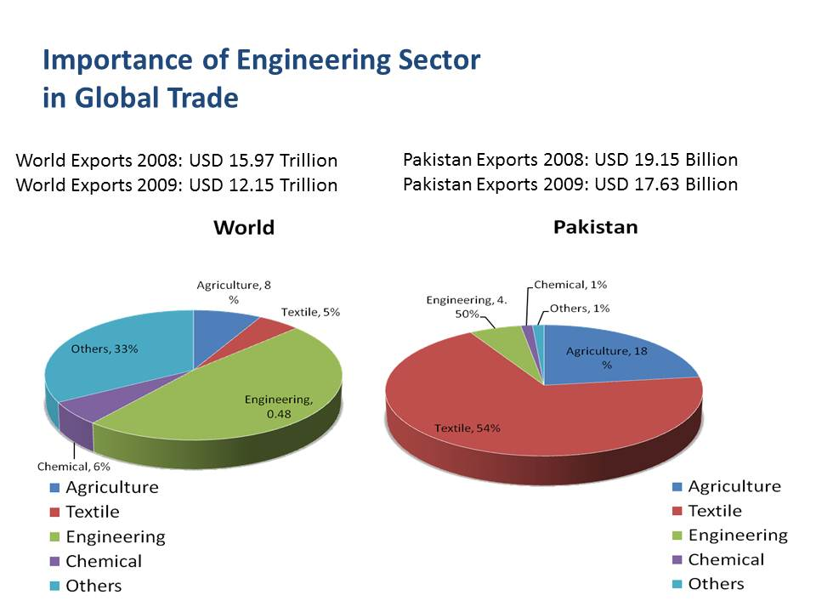

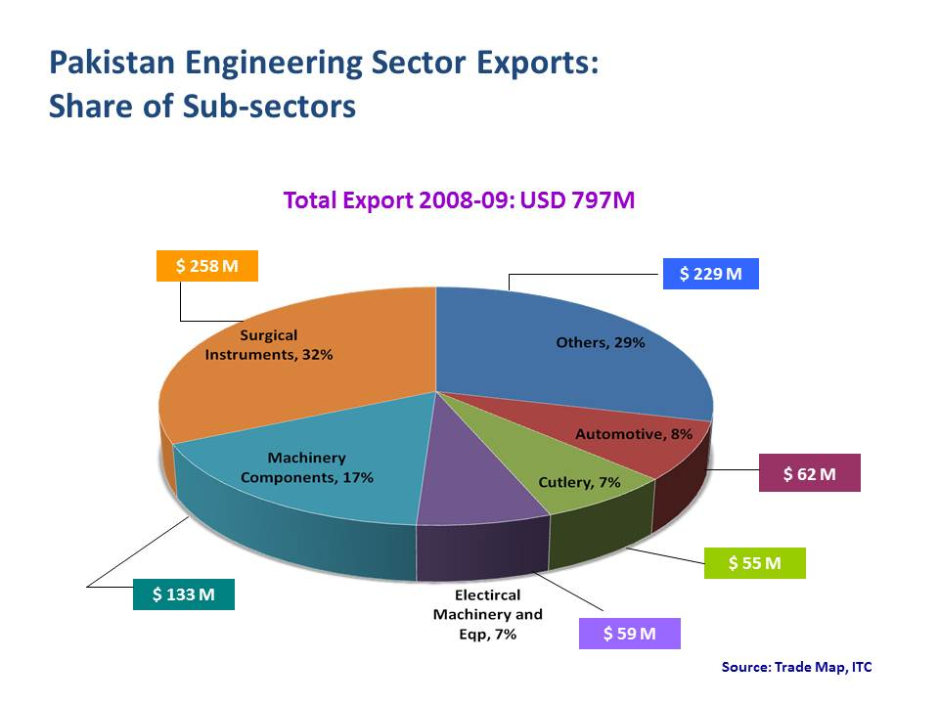
References:
- Science and technology based industrial vision of Pakistan’s economy and prospects of growth (2003)

- Siddiq, M., K., Bhaur, R., N., Minhas, B., S., (2011), Potential New Technology Growth Markets in Pakistan, IJCRB

- Kemal, A. R., Musleh ud Din and Usman Qadir (2002). Pakistan Country Report, Global Research Project, Pakistan Institute of Development Economics, Islamabad.

- Din, Musleh-ud and Kalbe Abbas, “The Uruguay Round agreement: Implications for Pakistan’s Textiles and Clothing Sector”. The Pakistan Development Review, 38:4, Part II (Winter 1999) pp. 823-833, PIDE, Islamabad.

- Small and Medium Enterprise Development Authority, “Textile Vision 2005”. Mid Term Review, July 19, 2002.

- Ministry of Planning & Development, Government of Pakistan, “Industrial Efficiency Improvement and Development Strategy Study: Textile Subsector Report”. Volume 18, Technical Assistance Project Cell, Islamabad.

- Mojica, F., J., (2010), The future of the future: Strategic foresight in Latin America, Centro de Pensamiento Estratégico y Prospectiva, Universidad Externado de Colombia, Calle 12 No. 1-17 Este, Bogotá, Colombia

- Kemal, A. R., Mahmood, Zafar, and Ahmad, Ather Maqsood, (1994)
“Structure of Protection, Efficiency, and Profitability. PIDE. The DRC estimates reported in the study pertain to the year 1990-91 and since then so such study has been carried out.

- Economic Survey of Pakistan, Ministry of Finance 2011-12.

- Business Recorder. 2011-04-11.

- World Bank Document

- World Bank Document. Retrieved 2010-07-29.
Annexure II

LIST OF EXPERT PANEL MEMBERS

Sr. No. | Title | Name | Designation | E- mail Address
 | Mr. | M. Saleem Khalid | Assistant Chief (Energy) Ministry of Industries & Production | mskhalidch@hotmail.com
 | Mr. | Qadir Hilal | Member Technology, PCSIR | membertechnology_pcsir@yahoo.com
 | Mr. | Muhammad Ather | Assistant Director, PSQCA Liaison Office RWP
 | Mr. | Abdul Rauf Chaudhary | Ex-President RCCI, Industrialist
 | Mr. | Waqas Masud | CEO, Fazal Industries
 | Dr. | Shimail Daud Arian | Executive Committee Member, Health Equips (Pvt) Ltd | shimail@healthequips.com
 | Mr. | Mahfooz Elahi | Director, Taxila Cotton Mills (Pvt) Ltd | mahfooz@comsats.net.pk
 | Mr. | M. Saeed Akhtar | Chairman, Chief Executive, SAL Securities (Pvt) Ltd | msal@isb.comsats.net.pk
 | Dr. | Zahid Mahmood | Professor, Bahria University | zahid@mail.au.edu.pk  mahmoodz@uws.edu.au
 | Dr. | Ali Ahsan | Associate Professor  And CEO, WISSEN Group | al_ahsan1@yahoo.com
 | Dr. | M. Shahid Khalil | Professor, UET Taxila | drmshahidk@gmail.com
 | Dr. | Abdul Hameed | Professor, QAU | hameedmrl@yahoo.com
 | Mr. | Qasim Wasim Dar | Managing Partner, Indus Fresh Farms | qasimdar@hotmail.com
 | Mr. | Zeeshan Khalid Masood | Executive Member, M/s United Sol (Pvt) Ltd | zeeshan@unitedsol.net

Annexure III

MEETINGS OF EXPERT PANEL MEMBERS

During the tenure of 6 months the expert panel on Industry met for six times to complete the Foresight exercise on Industry sector. The details of the meetings are provided below;

First expert panel meeting held on 18th May, 2010 at Pakistan Council for Science & Technology, Islamabad

Second expert panel meeting held on 02nd June, 2010 at Islamabad Chamber of Commerce & Industry, Islamabad

Third expert panel meeting held on 16th June, 2010 at Rawalpindi Chamber of Commerce & Industry, Rawalpindi

Fourth expert panel meeting held on 02nd September, 2010 at Pakistan Council for Science & Technology, Islamabad

Fifth expert panel meeting held on 15th December, 2010 at Pakistan Council for Science & Technology, Islamabad

Sixth expert panel meeting held on 19th March, 2011 at Pakistan Council for Science & Technology, Islamabad

